# **CS370: Assignment 1 - Documentation**

**Family Name:** Goh

**First Name :** Wei Zhe

**Email id : weizhe.goh@digipen.edu**

_________________________________________________________________________

Declaration:

I hereby declare that I adhere to the Academic Integrity Policy stated in the syllabus document. In addition, I also declare that the output images shown in this document are solely taken from the project that I have implemented for this assignment and the same output image will be generated when run in any Digipen PCs using the submitted project.



_________________________________________________________________________

# **Load Image:**

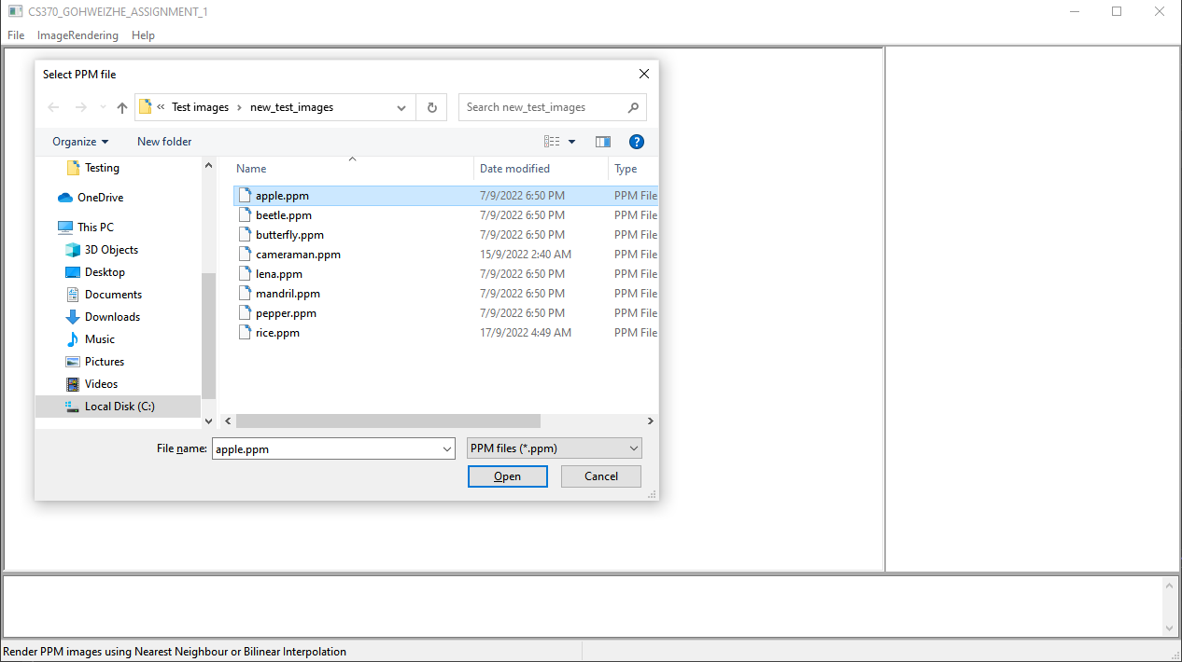

File Dialog pops up for users to select the image that they want to load.

# **Display Image on Screen:**

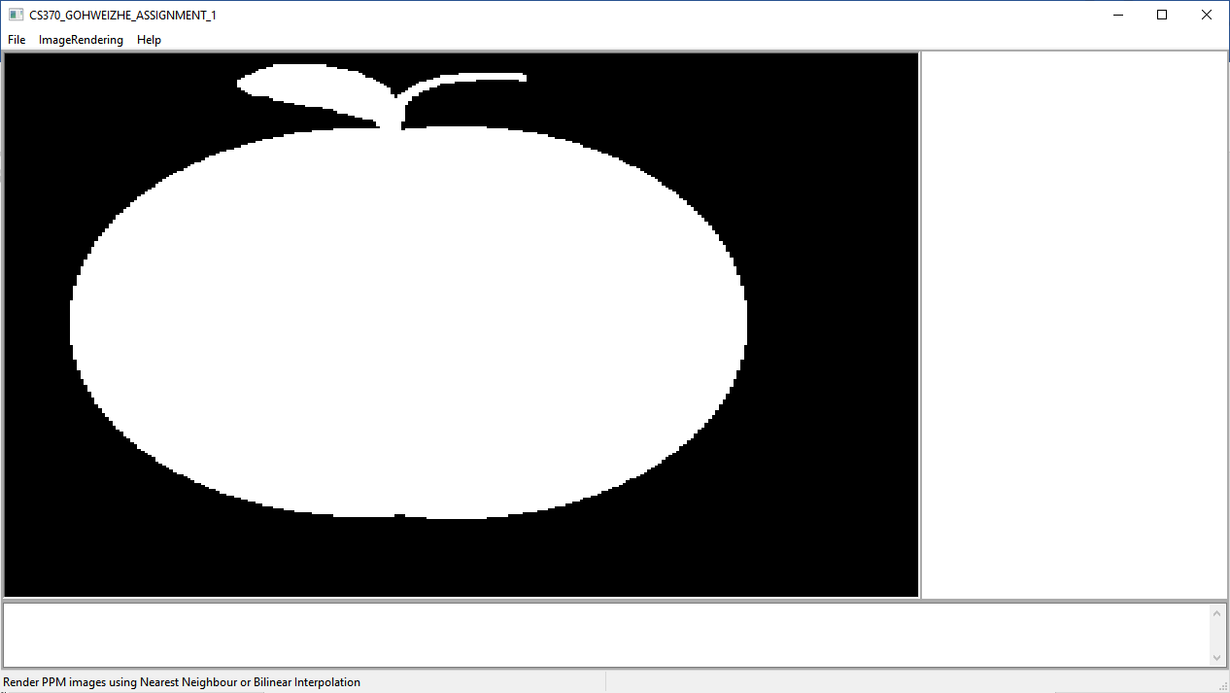

# **Save Image (Before):**

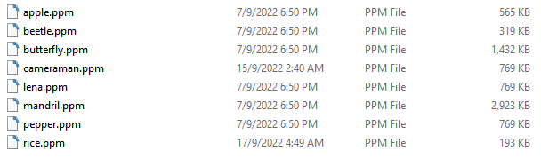

# **Save Image (After):**

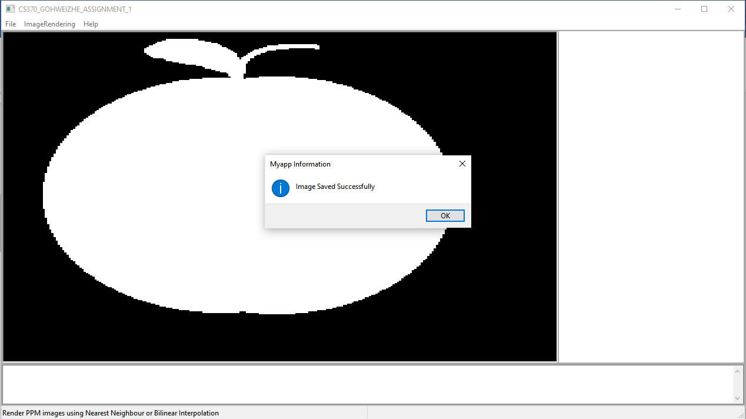

Message pops up “Image Saved Successfully.” to indicate image as been saved successfully.

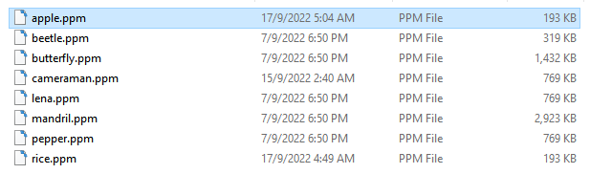

The time of apple.ppm is being updated when saved.

# **Save As Image:**

# 

File dialog pops up for users to input their file name.

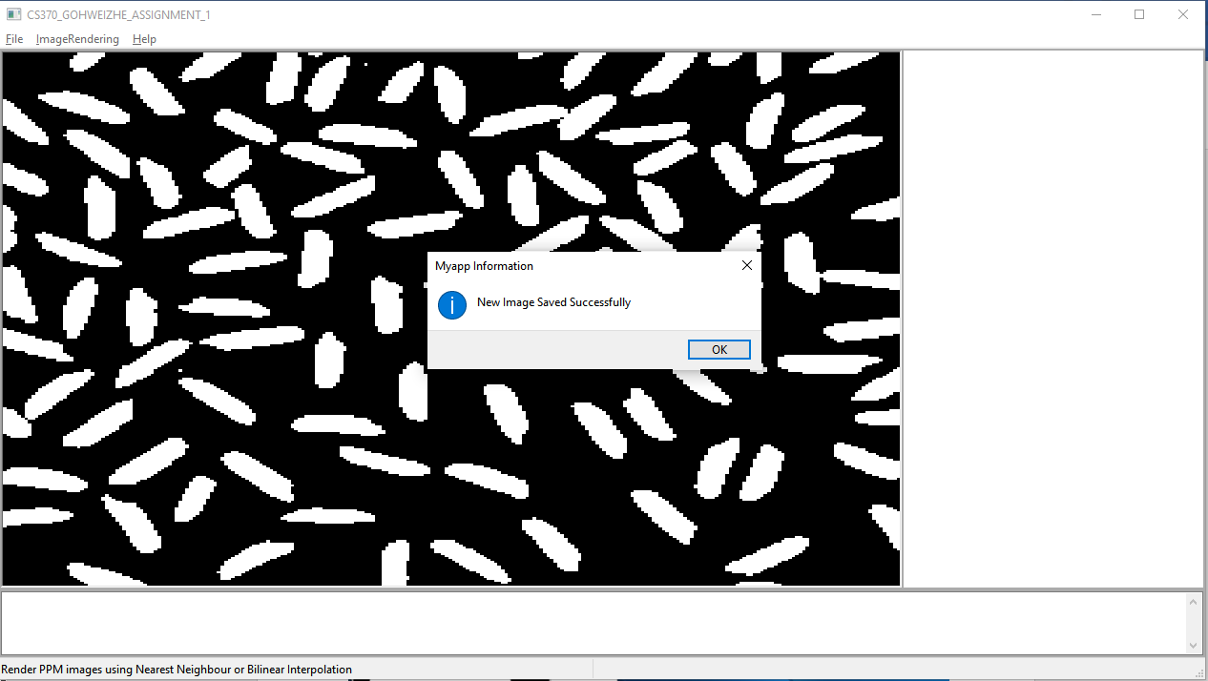

Message pops up “New image saved successfully.” to indicate a new image as been saved successfully.

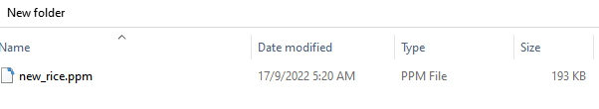

# **Image scaled to match client window at all times:**

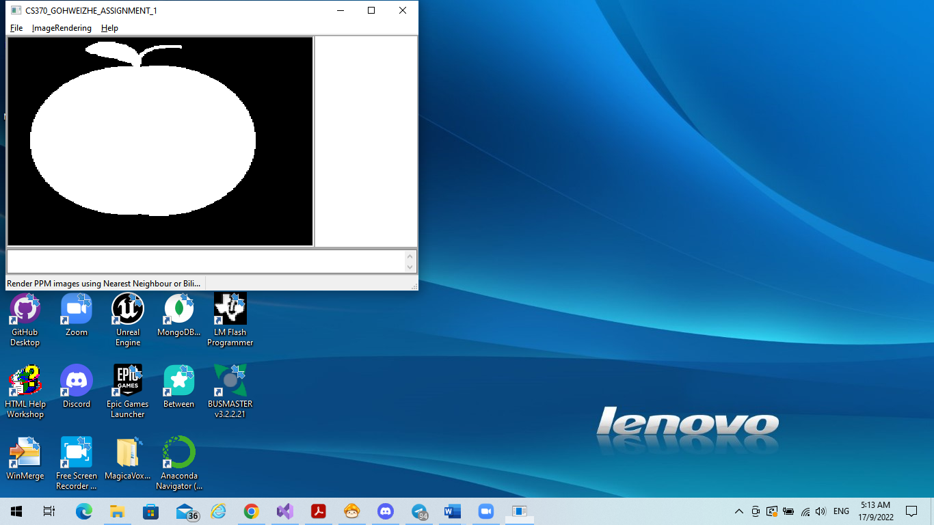

# **Nearest Neighbor Interpolation:**

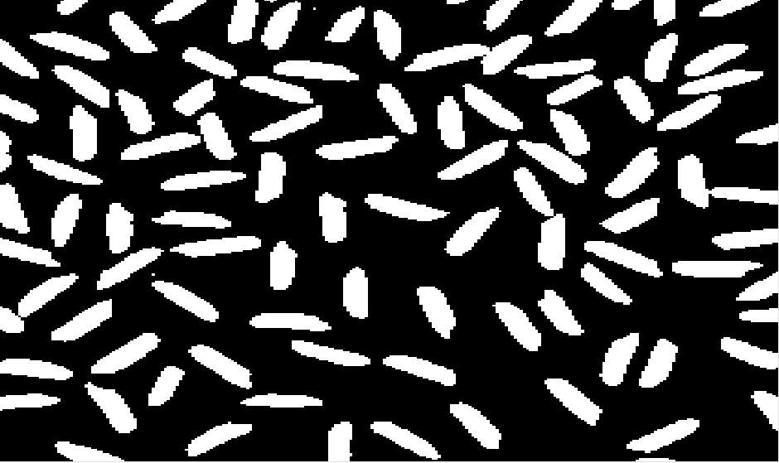

# **Bilinear Interpolation:**

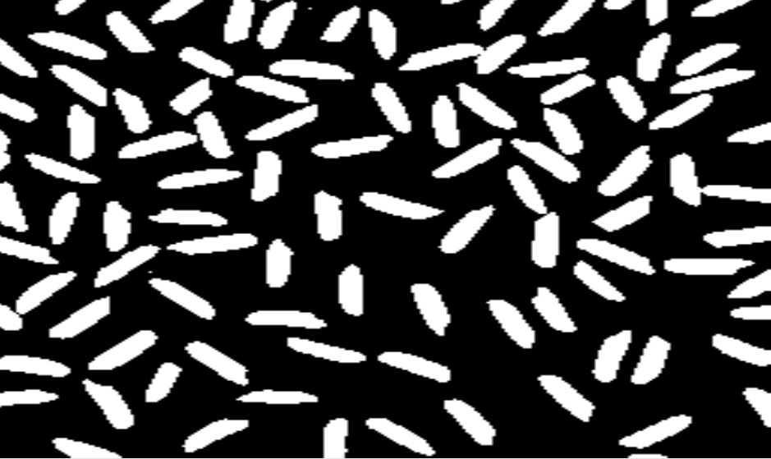

# **Bicubic Interpolation:**

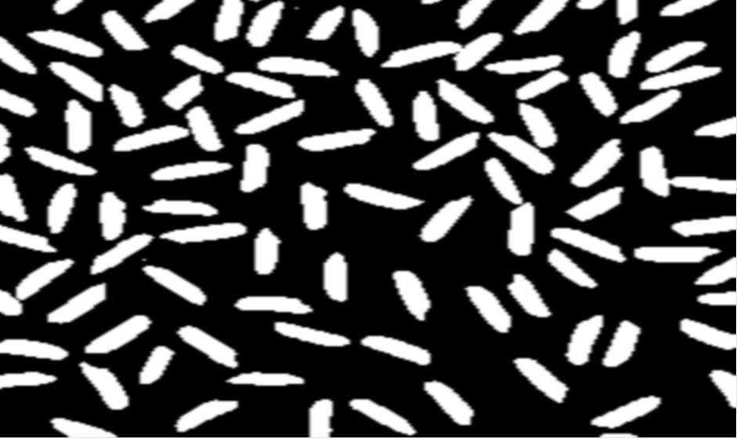

Additional Information to the Instructor:

1. Added Bicubic Interpolation
2. Program to recreate the sample executable as close as possible.